Interfacing Push buttons to 8051 Development kit using Polling


LAB # 03

Spring 2024
CSE-307L Microprocessor Based System Design Lab

Submitted by: Ali Asghar
Registration No.: 21PWCSE2059
Class Section: C

“On my honor, as student of University of Engineering and Technology, I have neither given nor received unauthorized assistance on this academic work.”

Submitted to:
Dr. Asif Ali Khan

Date:
5th March 2024

Department of Computer Systems Engineering
University of Engineering and Technology, Peshawar

Task 1:
Code:
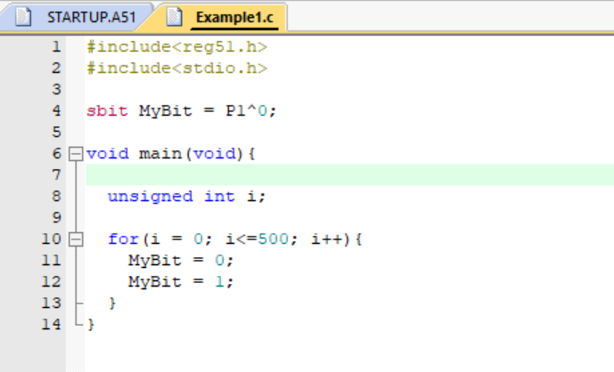

Output:
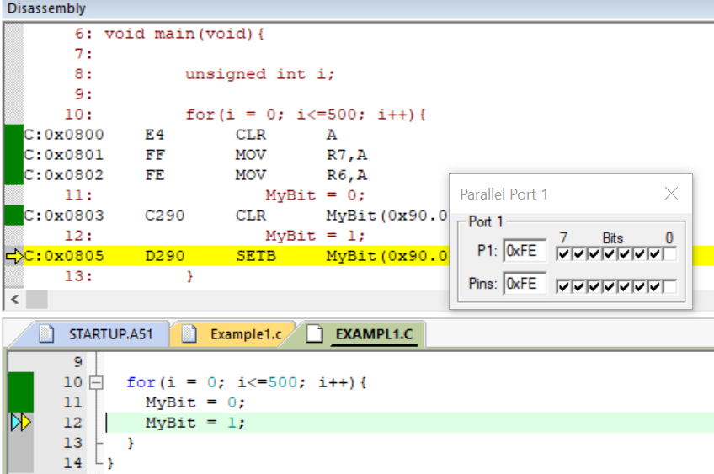
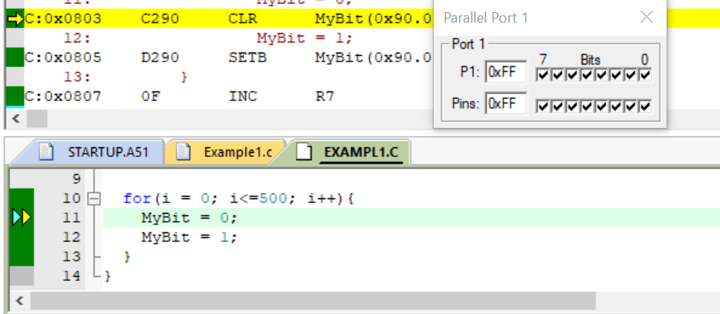
Task 2:
Code:
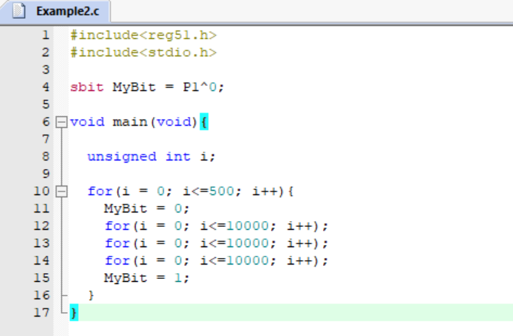

Output:
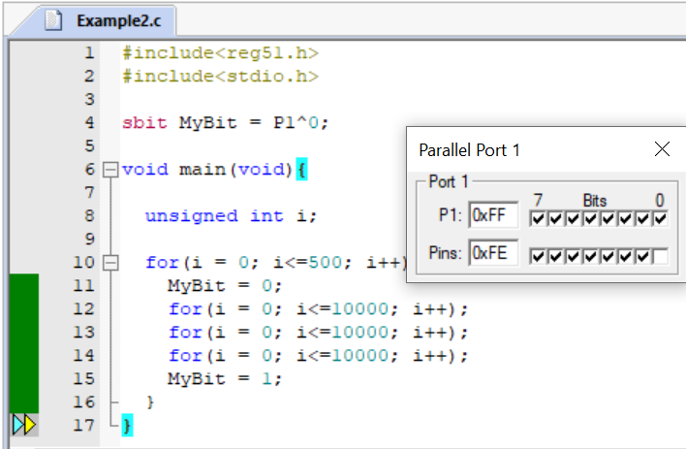

Task 3:
Code:
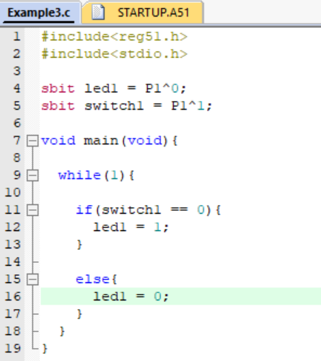

Output:
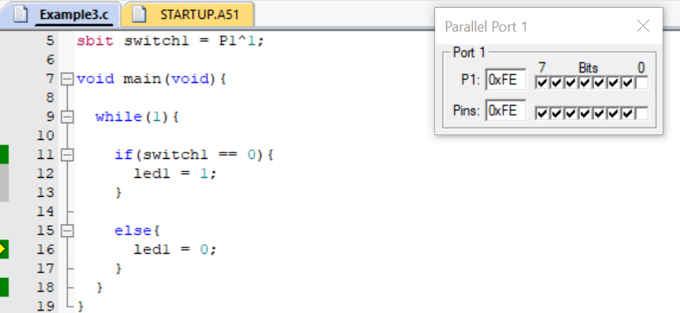
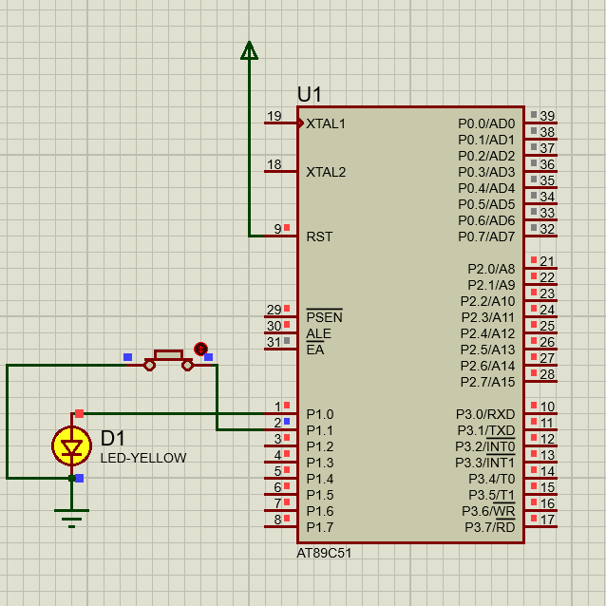
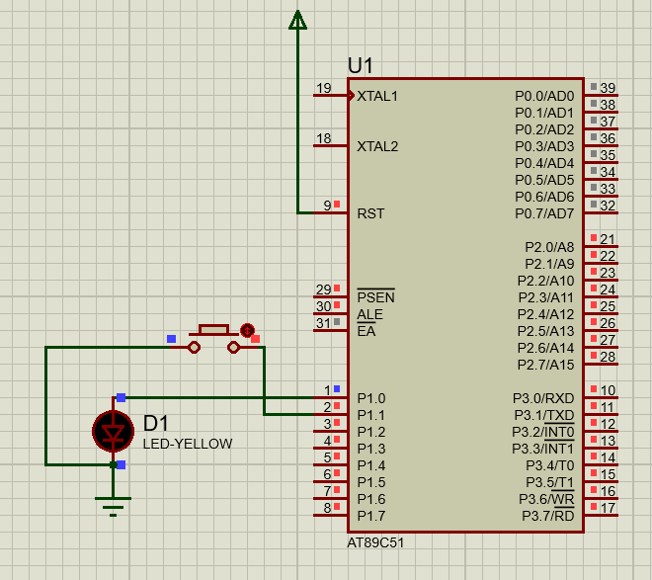
Proteus Simulation:

Task 4:
Code:
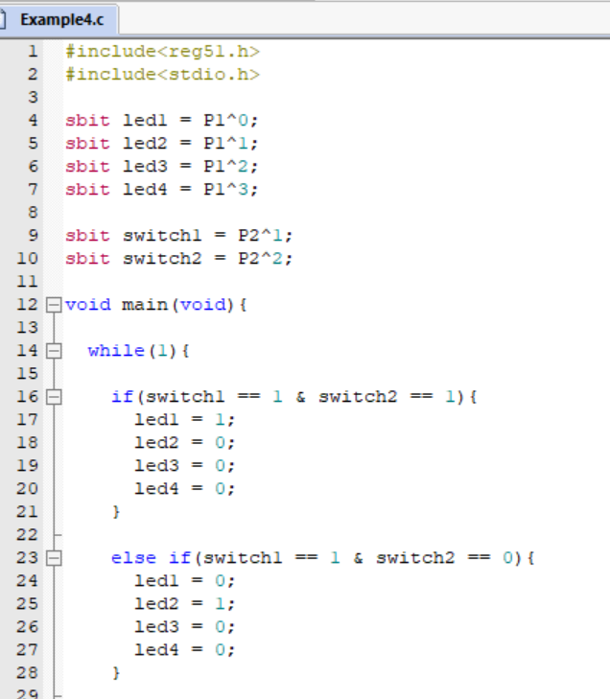
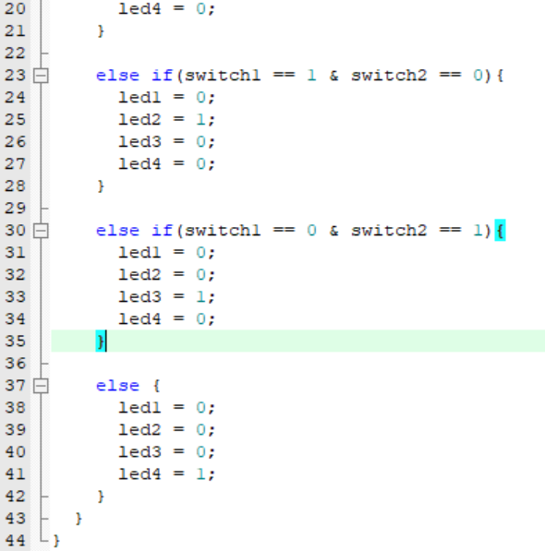

Output:
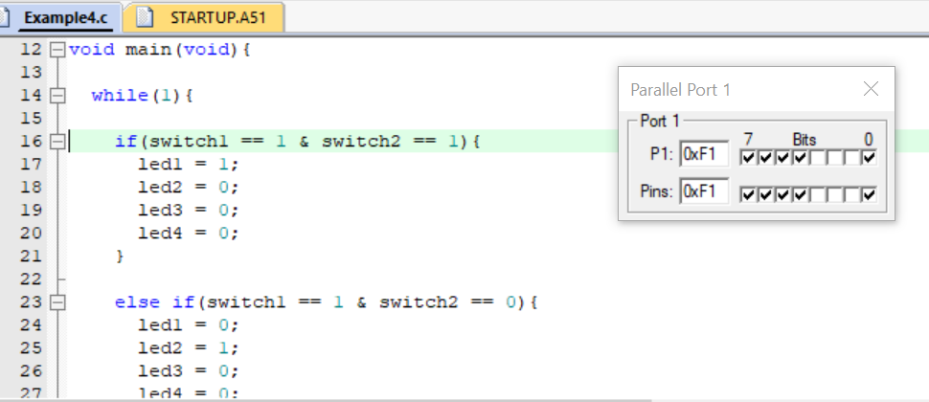

Proteus Simulation:
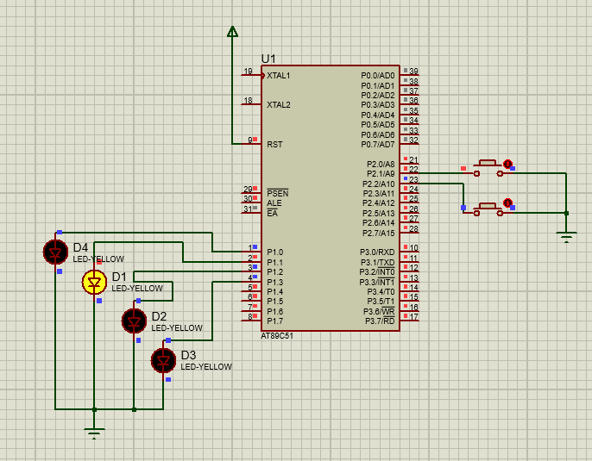

Task 5:
Attach 3 push button with PORT2 and 8 LED’s with PORT1 and turn ON led when the corresponding button are pressed, use polling for monitoring the buttons.

Code:
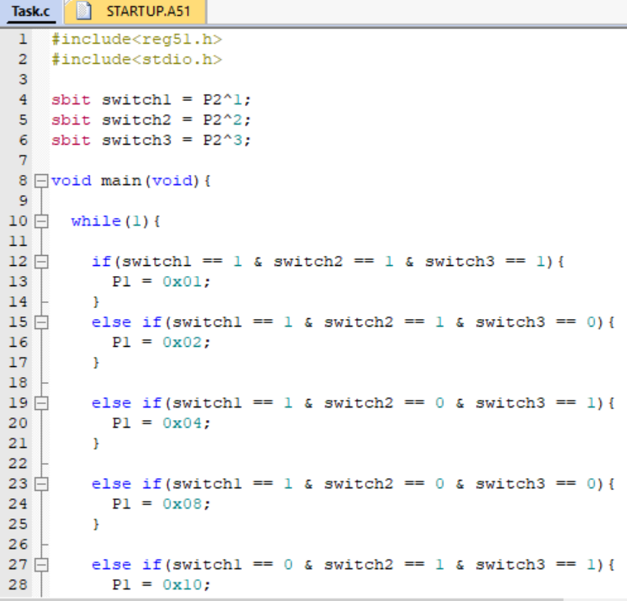
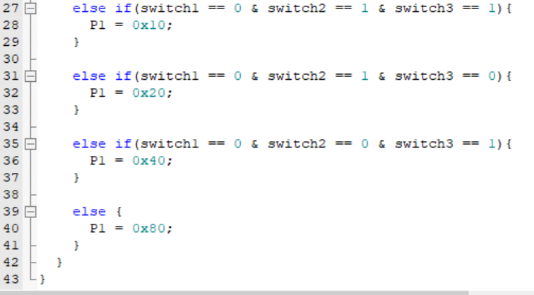

Output:
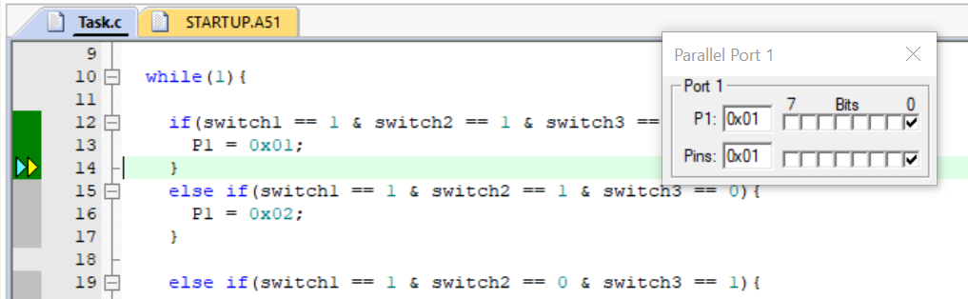

Proteus Simulation:
